MCQ
1. When the compiler cannot differentiate between two overloaded functions, it is called
a. Overloaded.
b. Destructed.
c. Overridden.
d. Ambiguous
2. The Instance (non-static) variable
a. It is a variable declared in the private section and can be accessed by any method in the same class
b. It is a variable declared in any section in a class and can be accessed by any method in the same class.
c. It is a variable declared inside any function and can be accessed by any other methods in the same class
d. It is a variable declared inside any function and cannot be accessed by any other methods in the same class
3. If you design a class that needs special initialization tasks, you will have to create a(n): a. Setter method.
b. Initializer Method.
c. Constructor.
d. Destructo
4. Which of the following statements is correct related to Object-Oriented concepts? a. Stand-alone function is one of the main parts of any Object-Oriented program. b. Every object is instantiated from a particular type.
c. It’s not necessary to make inheritance among classes.
d. All objects from the same concrete class may perform different actions
5. The best description for the association relation among the classes
a. When a class using object(s) from other class(es).
b. Objects that are declared using the default constructor.
c. An object from a class that is inherited from another class
d. b and c
6. For a derived class from a base class, it can directly access:
a. The private and protected members of the base class.
b. Only the private members of the base class.
c. Only the protected members of the base class.
d. The protected and public members of the base class
7. Which of the following refers to "Hiding data behind class methods?
a. Abstraction.
b. Encapsulation
c. Polymorphism
d. Inheritance
8. consider the following code:
class Base
{
public:
int x;
Base(int y)
{
x=y;
++x;
}
};
class child : public Base {
public:
child(int c)
{
x+=1;
}
void print()
{
cout<<”x=”<<x;
}
};
void main()
{
child c(1);
c.print();
}
a. x=1
b. x=2
c. x=3
d. x=4
e. Compilation Error.
9. 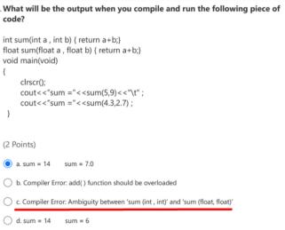10.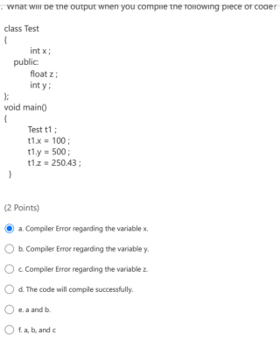
11.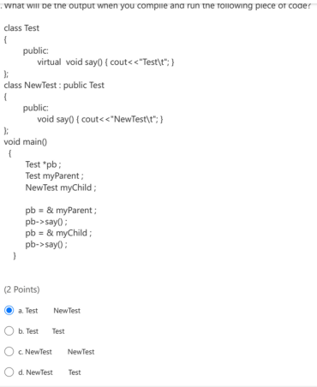
12. 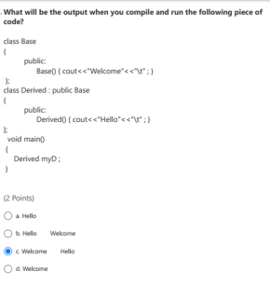13. 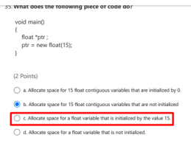14.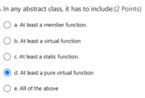
15. 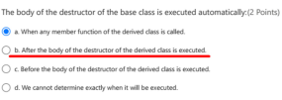16. 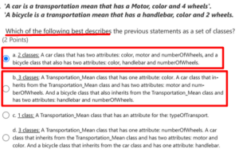17. 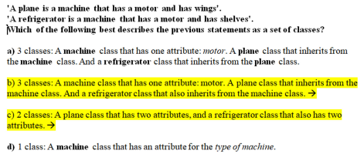18.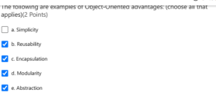
19. 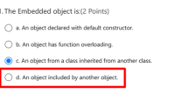20.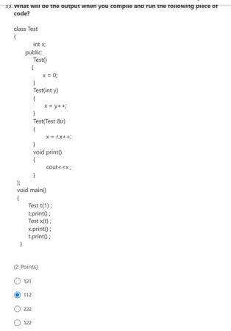
21. 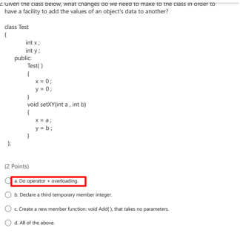22. 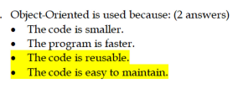23. 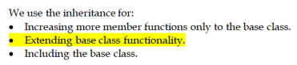24.
25. 26.
27. 28. 29.
30. 31. 32.
33. 34.
35. 36.
37. 38. 39.
40. 41. 42. 43.
44. 45.
46. 47. 48.
49. 50.
51.
52. 53. 54.
55. 56.
57.
58. 59.
60. 61. 62.
63. 64.
65.
specify the way of declared Stack s2(s1) // only call cpy ctor
66.
67.
68.

